Fake Out Cheesecake

ingredients
4 ounces cream cheese, at room temperature
Zest of 1 orange
Zest of 1 lemon
1 cup whole milk ricotta cheese
1/4 cup powdered sugar
4 individual graham cracker crusts
8 strawberries, sliced

preparation
In a bowl, combine cream cheese with the orange and lemon zest. Using a rubber spatula, beat in the ricotta cheese and powder sugar into the cream cheese.
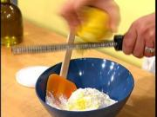
Divide the cheese mixture between the 4 individual graham cracker crusts and top each one with some of the sliced strawberries.
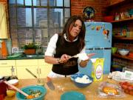
Yields 4 servings

