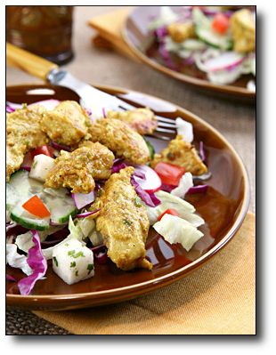
Ingredients

For the yogurt marinade:
- 1 cup plain nonfat yogurt
- 2 teaspoons Garam Masala powder
- 1 teaspoon ground ginger
- 1 teaspoon minced garlic
- 1 teaspoon ground turmeric
- 1 teaspoon salt
- 1 jalapeno chili, stemmed, seeded and finely minced (optional)
- 4 skinless, boneless chicken breast halves, gently flattened and cut into strips

For the salad:
- 3 cups shredded iceberg lettuce (1 small head)
- 3 cups shredded red cabbage (1 small head)
- 1 cup sliced radishes (1 bunch)
- 2 cups sliced cucumber (1 large)
- 1 small bunch scallions, minced
- 1 cup loosely packed cilantro leaves, finely chopped
- 1 1/2 cups diced jicama
- 1 tablespoon vegetable oil
- 2 to 3 small lemons, juiced, or to taste
- Salt and freshly ground black pepper, to taste

Directions
Make the marinade: In a bowl combine all ingredients. Arrange chicken in a shallow dish, add the marinade, and stir to coat with the marinade. Cover and chill while preparing the vegetables. Make the salad: In a large salad bowl combine all salad ingredients. In a nonstick skillet set over moderately high heat, warm the oil until it is hot. Add the chicken and marinade and cook, stirring, until the chicken is no longer pink. (Yogurt will separate.) Let simmer just until cooked. Transfer chicken together with pan juices to salad bowl and toss to combine. Add lemon juice and salt and pepper, to taste.

